PROJECT INFORMATION
SEVEN ON TOUR
"SEVEN is a unique, exciting and gripping way to raise awareness to the global and ever-present issue of women’s rights. The play captures and affect the audience trough the heartbreakingly but all too common stories of women from different parts of the world who’s rights are violated”

SEVEN the play
Seven is a documentary play based on the real life stories of seven women's rights activists from Nigeria, Afghanistan, Guatemala, Russia, Pakistan, Northern Ireland and Cambodia.

In the project Seven on Tour the play is presented as a reading, every time performed/read by seven new persons who lend their voices to the stories of these marginalized women. The readers often represent different aspects of society, e.g. politicians, activists, athletes, journalists and survivors of domestic violence. Each performance is a collaboration between stakeholders of the issues from civil society, government agencies, municipalities, student organizations etc. The performance of Seven and touring concept is developed by Swedish director and producer Hedda Krausz Sjögren in cooperation with the National Touring Theatre (Riksteatern) and the Swedish Institute.

The play was created in 2007 by seven playwrights: Paula Cizmar, Catherine Filloux, Gail Kriegel, Carol K. Mack, Ruth Margraff, Anna Deveare-Smith and Susan Yankowitz with the support of Vital Voices Global Partnership.

SEVEN the project
The aims of the performances are to bring women’s rights issues higher on the political and media agenda, raise awareness and engagement, and to stimulate the debate on women’s role in society.

The Swedish Institute, The Swedish Ministry for Foreign Affairs and Amnesty International, United Nations Development Program, women’s shelters etc. have all cooperated around Seven on Tour to promote democracy and human rights. The project has improved bilateral cooperation, as well as strengthened cooperation between stakeholders from grass root to governmental level and empowered individual activists in their local communities.

The readings are often linked to activities with a focus on human rights such as panel discussions, seminars and lectures for students.

SEVEN the women

FARIDA AZIZI, AFGHANISTAN
Farida Azizi became an activist fighting the marginalization of women under Taliban rule in her native country. Because of threats to her life, she has gained asylum and now lives in the United States with her two children, working on women’s rights and peacebuilding in Afghanistan.

INEZ MCCORMACK, NORTHERN IRELAND, 1943 - 2013
Inez McCormack who grew up in a Protestant family in Belfast, did the unthinkable and married a Catholic. From the 60’s she was an activist for women’s and human rights, labour, and social justice. She was President for of the Irish Congress of Trade Unions. Ms. McCormack played a critical role in the 1998 Good Friday Peace Accords. She continued her struggle for the underpriviliged until she passed away in January 2013 after a short illness.

MARINA PISKLAKOVA - PARKER, RUSSIA
In 1993, against tremendous odds, Marina Pisklakova-Parker founded the first hotline for victims of domestic violence, which has since grown into Center ANNA, part of a coalition that has provided crisis and counselling services for 100,000 Russian women.

ANNABELLA DE LEON, GUATEMALA
Annabella raised herself and her family out poverty by getting an
education. A congresswoman since 1995, she has has received death threats because of her fight against corruption and for the rights of the poor, particularly women and indigenous peoples.

MUKHTAR MAI, PAKISTAN
Mukhtar Mai was gang-raped by four men and forced to walk home almost naked in retribution for an alleged “honour crime,” Ms. Mai and her harrowing story grabbed headlines across the world. Instead of taking the traditional women’s route of committing suicide, she brought her rapists to justice, built schools to improve the condition of women, and became an advocate for education in her country.

MU SOCHUA, CAMBODIA
Mu Sochua, a former Minister of Women’s Affairs in Cambodia
(one of only two women in the cabinet), was co-nominated in 2005 for the Nobel Peace Prize for her work against sex trafficking in Cambodia and neighboring Thailand. MP Mu Sochua, after door-to-door visits to 482 villages, won a seat in Parliament in July, 2008.

HAFSAT ABIOLA, NIGERIA
Hafsat Abiola, Nigeria, an advocate for human rights and democracy following the murder of her activist parents, founded the Kudirat Initiative for Democracy, which provides skills-training and leadership opportunities for young women across Nigeria.

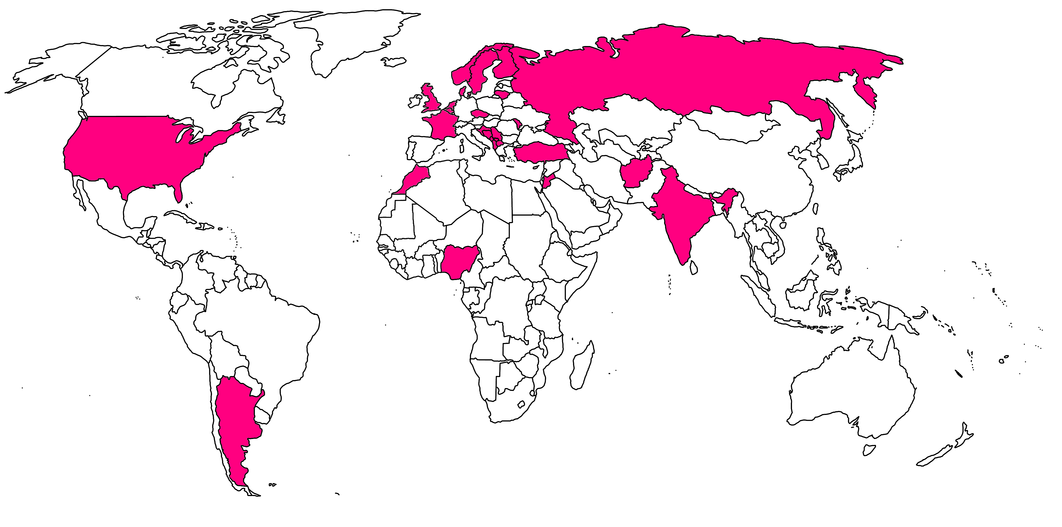RESULTS BY SEVEN ON TOUR 2009 – 2015

- Performed in 28 countries, including Afghanistan, Serbia, Russia and Turkey.
- Translated into 22 languages.
- Over 600 women and men have been on stage portraying the activists in the play.
- Over 100 organizations, government agencies etc. have been involved locally and/or nationally in Seven on Tour.
- Performed in the Swedish parliament by male politicians, in the EU parliament by MPs from seven countries, in the Serbian parliament by activists, journalists and politicians, in the Ukraine parliament by politicians and activists.
- The best performing single project in terms of people reached (over 20 million) and advertising value (11,5 million SEK) out of all projects by the Swedish Institute in 2013.
- Promoted policy changes and implementation of protocol for the on protection of women victims of violence. (See further below).

SEVEN readers – a selection

Haji Mohammad Abdu Member of National Parliament, Afghanistan (Mazar-e-Sharif, 2013)
Nawal el Moutawakel Olympic Champion, vice president International Olympic Committee, former Minister of Sports, Morocco (Rabat, 2013)
Mikael Damberg Minister of economic affairs and innovation, Sweden (Swedish Parliament, 2010 and Almedalen, 2011)
Birgitta Ohlsson Former minister for EU-affairs, Sweden (Stockholm, Uppsala, Haag, Gothenburg 2009, 2010, 2011)
Vladimir Pozner journalist, broadcaster anchor for Russia TV Channel 1, commentator on NBC, and ambassador for raising awareness around HIV/AIDS (St Petersburg 2011)
Jadranka Kosor Former Prime Minister, Croatia (Zagreb, 2013)
Meryl Streep Oscar-winning actress, USA (New York 2010)
Esma Redzepova World renown Roma singer, Macedonia (Skopje 2013)
Ramadan Ramadani Imam and journalist, Macedonia (Skopje 2013)
Foto Strakosha Ex-football champion, Albania (Tirana 2013)

EXAMPLE Seven on Tour – the Balkan 2013

Initially, a total of ten performances were planned in Macedonia, Albania, Bosnia & Herzegovina, Croatia, Serbia and Kosovo during November 2013. However, three additional ones were added after massive public and political interest, amongst them a reading in the Serbian parliament..

The readings gained wide media coverage including several national talk shows, in depths features in news channels such as Al Jazeera, Balkan Insight and several page spreads in monthly magazines such as Elle and Cosmopolitan. The president of Kosovo was introductory speaker at the Pristina premiere, and many more high level officials have been involved around the tour.

Reading - Novi Pazar, Serbia, November 28, 2013.
Novi Pazar is a community of 100 000 people, it is a polarized town, tradition and patriarchy has a strong influence. Anyone questioning the status quo runs the risk of being demonized by formal and informal community leaders.

Project owners/organizers
The Embassy of Sweden, the Swedish Institute, Hedda Krausz Sjögren (producer), Serbian director Anja Susa and the local Serbian organisation Youth Initiative for Human Rights.

Readers
Serbian journalists, politicians, actresses and local activist Aida Corovic, has a strong history of standing up for vulnerable groups and women in her society.

Audience (full house >300 people)
The mayor, Swedish chargé d’affairs, activists, local staff from the mayor’s office, students, general public, police.

Results

“A public conversation between these groups [activists and local institutions] has never happened here before. We have taken a step towards real change for the situation of women who suffer abuse in Novi Pazar”. Audience member, Novi Pazar.

Following the performance a panel discussion took place, which was the first of its kind in the community. It was organized in cooperation with local women’s organizations from Novi Pazar in order to open a discussion about the lack of local institutional capacities that should provide support and protection to women victims of violence in Novi Pazar. On the panel there were representatives of the local institutions (police, local government, medical center, women’s organization). The final statement of one panellist was a call for another meeting within two months. After the performance and panel in Novi Pazar in December 2013, the representatives intensified formal meetings in order to find an adequate way of cooperation.
In May 2014 in the City Hall of Novi Pazar the Protocol on cooperation to protect women victims of violence in intimate relationships was signed by all relevant social actors - representatives of the judiciary, prosecution, police, non-government sector, the health center, representatives of primary and secondary schools, and local government.
As pointed out by Director of the Center for Social Work, Adnan Dizdarevic, this protocol is the first step towards solving common problems of women victims of domestic violence in Novi Pazar, and presents an example of the association at the local level, in order to solve specific problems.
Alma Junis, president of the NGO Together, said that the signing of this protocol is something that was lacking in the system of protection for victims of domestic violence, because some institutions have previously not responded adequately, and she expressed satisfaction about demonstrating good will to cooperate in the future and a much more serious approach to this problem.

IMPLEMENTATION
Before each performance the local project team puts together a unique ensemble to present the play. Every performance is different depending on context and ensemble.

Rehearsals
One or two group rehearsal of maximum 3 hours possibly complimented with one individual meeting.

Presentation
The presentation is very sparse: seven persons sitting on chairs, reading the play out loud from the manuscript to the audience. The reading is about 1hour 10 minutes.

Reference material
For more information about the project, including TV-clips and more, please visit our website or Vimeo-account.

For any further questions, please don’t hesitate to contact me at any time.

With warm regards,

Hedda Krausz Sjögren, director, producer

Hedda Produktion AB
Cell: +46 (0) 70 673 73 72
Skype: heddasjogren
e-mail: hedda@hedda.nu
Hedda Production website: www.hedda.nu
Seven website: www.sevenwomen.se
Twitter: ProdHedda

